Unit 2: Organization, Management and Network Enterprise

Information Systems in Global Business Today

Introduction:
Computers and Information technology (IT) are changing every aspect of our lives from entertainment to shopping, from the work we do and where we do it, to how we communicate with friends and relatives. Many companies are remodeling their businesses and information systems with the Internet in mind. IT is dramatically changing the business landscape and significantly affecting strategic options and creating opportunities and issues that managers need to address in many aspects of their business.
Some of the key impacts of technology and the implications for management are:
- Business Strategy - collapsing time and distance, enabling electronic commerce.
- Organization Culture - encouraging the free flow of information.
- Organization Structures - making networking and virtual corporations a reality.
- Management Processes - providing support for complex decision-making processes.
- The workplace - allowing work from home and on the move.

The real world of information system
- Information systems have become as integrated into our daily business activities as accounting, finance, operations management, marketing, human resource management, or any other major business function.
- Information technologies, including Internet-based information systems, are playing vital and expanding roles in business.
- Information technology can help all kinds of businesses improve the efficiency and effectiveness of their business processes, managerial decision making, and workgroup collaboration, which strengthens their competitive positions in rapidly changing marketplaces.
- Information technologies and systems are, quite simply, an essential ingredient for business
success in today’s dynamic global environment.

What Is an Information System?
- An information system (IS) can be any organized combination of people, hardware, software, communications networks, data resources, and policies and procedures that stores, retrieves, transforms, and disseminates information in an organization.

The Fundamental Roles of IS in Business
There are three vital roles that information systems can perform for a business enterprise:
- Support of business processes and operations.
- Support of decision making by employees and managers.
- Support of strategies for competitive advantage.

Opening Case: The New Yankee Stadium Looks to the Future

- The challenges facing the New York Yankees and other baseball teams show why information systems are so essential today. Major league baseball is a business as well as a sport, and teams such as the Yankees need to take in revenue from games in order to stay in business.
- To increase stadium attendance and revenue, the New York Yankees chose to modernize Yankee Stadium and rely on information technology to provide new interactive services to fans inside and outside the stadium.
- These services include high-density television monitors displaying live game coverage; up-to-date sports scores, video, promotional messages, news, weather, and traffic information; touch screens for ordering food and merchandise; interactive videoconferencing technology for connecting to fans and the community; mobile social networking applications; and, eventually, data and video broadcast to fans’ home television sets and mobile handhelds.
- The Yankees’ Web site provides a new channel for interacting with fans, selling tickets to games,
and selling other team-related products.
- It is also important to note that these technologies changed the way the Yankees run their business. Yankee Stadium’s systems for delivering game coverage, information, and interactive services changed the flow of work for ticketing, seating, crowd management, and ordering food and other items from concessions.
- These changes had to be carefully planned to make sure they enhanced service, efficiency, and profitability.

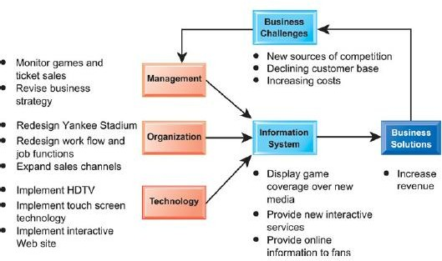

The Role of Information Systems in Business Today:
- Information systems are essential for conducting day-to-day business as well as achieving strategic business objectives.
- Some firms, such as Amazon and ETrade, would be nonexistent without information systems.

- It is difficult to imagine some service industries, such as finance, insurance, and real estate industries, could not operate without information systems.
- The ability of a firm to use IT is connected with the firm's ability to implement corporate strategy.
- As electronic business and electronic commerce grow in popularity and more firms digitize their operations, having useful information is becoming even more important to the global business community.
- Business firms invest heavily in information systems to achieve six strategic business objectives: operational efficiency, new products, services & business models, customer and supplier intimacy, better decision making, competitive advantage, and survival.

How Information Systems Are Transforming Business:
- Wireless communications, including computers and mobile hand-held computing devices, are keeping managers, employees, customers, suppliers, and business partners connected in every way possible.
- Email, online conferencing, the Web, and the Internet, are providing new and diverse lines of communication for all businesses, large and small.
- Through increased communication channels and decreased costs of the communications, customers are demanding more of businesses in terms of service and product, at lower costs.
- E-commerce is changing the way businesses must attract and respond to customers.

What’s New in Management Information Systems?
The use of technology now extends far beyond the simple desktop computer, especially in the business world. There are three interrelated changes that are affecting companies worldwide:
- The emerging mobile digital platform: More and more business computing is moving from PCs and desktop machines to mobile devices like iPhones, iPads, Smart Phones etc. Managers are increasingly using these devices to coordinate work, communicate with employees, and provide information for decision making.
- Growth of businesses use of Big Data: The use of Big Data — large pools of data that can be brought together and analyzed to discern patterns and make better decisions — will become the basis of competition and growth for individual firms, enhancing productivity and creating significant value for the world economy by increasing the quality of products and services. All companies need to take Big Data and its potential to create value seriously if they want to compete. For example, some retailers embracing big data see the potential to increase their operating margins.
- Growth of cloud computing: Cloud computing is a type of computing that relies on sharing computing resources rather than having local servers or personal devices to handle applications. Main objective is to provide different services — such as servers, storage and applications —to an organization's computers and devices through the Internet. The cloud has changed the fundamental nature of computing and how business gets done. According to the research done by Global Industry Analysts Inc, cloud computing came as a boon for companies during tough economic and financial climate, given that the technology can potentially reduce IT costs by over 35%.

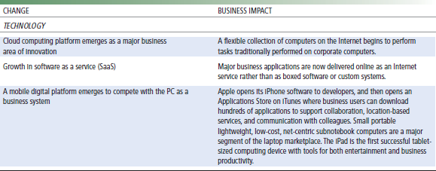

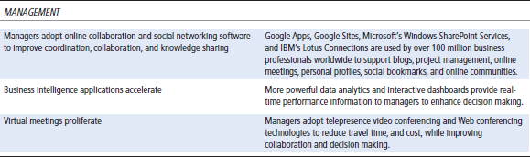
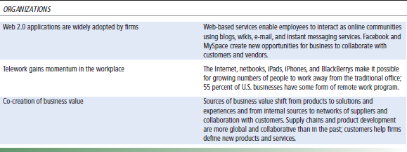

Globalization Challenges and Opportunities: A Flattened World
- Customers no longer need to rely on local businesses for products and services. They can shop at any time and any day of a week for virtually anything and have it delivered to their door or desktop.
- Companies can operate at any time from any geographic location around the world. Jobs can just as easily move across the state or across the ocean.
- The emergence of the Internet into a full-blown international communications system has drastically reduced the costs of operating and transacting business on a global scale.

- The move to a global economy has been facilitated by advanced telecommunications networks and particularly by the Internet.
- At the same time globalization adds challenges to businesses. In a global market, cost of labor varies widely among countries.
- In general, labor costs are higher in developed countries than in developing countries. Many labor- intensive industries have moved their operations to countries with low labor costs.
- Also, developed countries usually pay high fringe benefits to employees, which make the cost of doing business even higher.
- A growing percentage of the economy of the United States and other advanced industrial countries in Europe and Asia depends on imports and exports.
- In 2010, more than 33 percent of the U.S. economy resulted from foreign trade, both imports and exports. In Europe and Asia, the number exceeded 50 percent.
- More than half of Intel’s revenues in 2010 came from overseas sales of its microprocessors. Eighty percent of the toys sold in the U.S. are manufactured in China, while about 90 percent of the PCs manufactured in China use American-made Intel or Advanced Micro Design (AMD) chips.
- In the past decade, the United States lost several million manufacturing jobs to offshore, low- wage producers.
- In a normal year, about 300,000 service jobs move offshore to lower wage countries, many of them in less-skilled information system occupations, but also including “tradable service” jobs in architecture, financial services, customer call centers, consulting, engineering, and even radiology.
- Internet service firms, such as Google and eBay, are able to replicate their business models and services in multiple countries without having to redesign their expensive fixed-cost information systems infrastructure.
- Briefly, information systems enable globalization.

The Emerging Digital Firm:
- A digital firm is one in which nearly all of the organization’s significant business relationships with customers, suppliers, and employees are digitally enabled, and key corporate assets are managed through digital means.
- These digital networks are supported by enterprise class technology platforms that have been leveraged within an organization to support critical business functions and services.
- Some examples of these technology platforms are Customer Relationship Management (CRM), Supply Chain Management (SCM), Enterprise Resource Planning (ERP), Knowledge Management (KMS), Enterprise Content Management (ECM), and Warehouse Management System (WMS).
- Making a firm digital is not about just adding a computer system to the mix. Throwing a computer system at outdated business processes is exactly the wrong thing to do.
- A truly digital firm has several characteristics that distinguish it from most of the firms claiming to be digitized:
  - Significant business relationships with customers, suppliers, and employees are digitally enabled and mediated.

  - Core business processes are accomplished through digital networks spanning the entire organization or linking multiple organizations.
  - Key corporate assets – intellectual property, core competencies, and financial and human assets – are managed through digital means.
  - They sense and respond to their environments far more rapidly than traditional firms.
  - They offer extraordinary opportunities for more flexible global organization and management, practicing time-shifting (business being conducted 24x7) and space-shifting (business being conducted globally or beyond traditional geographic boundaries).

Strategic Business Objectives of Information Systems:
- Strategic planning for an organization involves long-term policy decisions, like location of a new plant, a new product, diversification etc.
- Information technology has played an important part in the U.S. and global economies.
- Companies rely on IT for fast communications, data processing and market intelligence.
- Specifically, business firms invest heavily in information to achieve six strategic business objectives:
  - Operational excellence
  - New products, services, and business models
  - Customer and supplier intimacy
  - Improved decision making
  - Competitive advantage
  - Survival Operational Excellence:
- This relates to achieving excellence in business in operations to achieve higher profitability. For example, a consumer goods manufacturer may decide upon using a wide distribution network to get maximum reach to the customers and exposure. A manufacturing company may pursue a strategy of aggressive marketing and mass production.
New Products, Services, and Business Models:
- This is part of growth strategy of an organization.
- With the help of information technology, a company might even opt for an entirely new business model, which will allow it to establish, consolidate and maintain a leadership in the existing market as well as provide a competitive edge in the industry.
- As successful as Apple Inc., BestBuy, and Walmart were in their traditional business, they have all introduced new products, services, and business models that have made them even more competitive and profitable.
Customer and Supplier Intimacy:
- When a business really knows its customers, and serves them well, the way they want to be served, customers generally respond by returning and purchasing more. The result is increased revenues and profits.

- Likewise with suppliers: The more a business engages its suppliers, the better the suppliers can provide vital inputs. The result is a lower cost of doing business.
- JC Penney is an excellent example of how the use of information systems and technologies are extensively used to better serve suppliers and retail customers. Its information system digitally links the supplier to each of its stores worldwide. Suppliers are able to ensure the continuous flow of products to the stores in order to satisfy customer demands.
Improved Decision Making:
- A very important pre-requisite of strategic planning is to provide the right information at the right time to the right person, for making an informed decision.
- Well planned Information Systems and technologies make it possible for the decision makers to use real-time data from the marketplace when making decisions.
- Previously, managers did not have access to accurate and current data and as such relied on forecasts, best guesses, and luck.
- The inability to make informed decisions resulted in increased costs and lost customers. Competitive Advantage:
- Doing things better than your competitors, charging less for superior products, and responding to customers and suppliers in real time all add up to higher sales and higher profits that your competitors cannot match.
- Toyota and Walmart are prime examples of how companies use information systems and technologies to separate themselves from their competition. Toyota worked its way to top of its industry with the help of its legendary information system. Walmart is the most efficient retail store in the industry based in large part on how well it uses its information resources.
Survival:
- Business firms also invest in information systems and technologies because they are necessities
of doing business. Sometimes these “necessities” are driven by industry-level changes.
- For instance, after Citibank introduced the first automated teller machines (ATMs) in the New York region in 1977 to attract customers through higher service levels, its competitors rushed to provide ATMs to their customers to keep up with Citibank.
- Today, virtually all banks in the United States have regional ATMs and link to national and international ATM networks.
- Providing ATM services to retail banking customers is simply a requirement of being in and surviving in the retail banking business.
- Firms turn to information systems and technologies to provide the capability to respond to these challenges.
Perspective’s on Information System
- Data is a collection of raw facts that may or may not be meaningful for managers. Input to any system may be treated as Data. It is very difficult to understand data and needs to be processed to understand. Data may not be in the order.

- Information is the outcome derived after processing the data and is always meaningful. Output after processing the system is Information. Processing is performed by performing arithmetic logical calculations on data of simply by rearranging the data. It is very easy to understand information. Information should be in the order.
- For example, researchers who conduct market research survey might ask a member of the public to complete questionnaires about a product or a service. These completed questionnaires are data; they are processed and analyze in order to prepare a report on the survey. This resulting report is information.
Another Example:
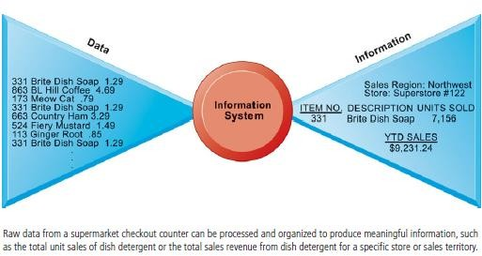

Characteristics of Information:
- Availability/accessibility
- Accuracy
- Reliability
- Relevance/appropriateness
- Completeness
- Level of detail/conciseness
- Presentation
- Timing

Information Systems:
- In a simplest sense, a system that provides information to people in an organization is called information system (IS).
- It can be defined as a collection of interrelated components working together to collect, process, store, and disseminate information to support decision making, coordination, control, analysis, and visualization in an organization.

- Information systems in organizations capture and manage data to produce useful information that supports an organization and its employees, customers, suppliers and partners.
- So, many organizations consider information system to be the essential one. Information systems produce information by using data about significant people, places, and things from within the organization and/or from the external environment to make decisions, control operations, analyze problems, and create new products or services.
- As already mentioned, Information is the data shaped into a meaningful form. Data, on the other hand, are the collection of raw facts representing events occurring in organizations or the environment before they have been organized and arranged into a form that people can understand and use.
- The three basic activities to produce information in an information system are input, processing, and output.
  - Input captures or collects raw data from within the organization or from its external environment for processing. Normally input is hardware component of information systems.
  - Processing converts raw data into the meaningful information. Normally processing is done by software. Processing is done either by performing arithmetic or logical calculations on the data or by simply rearranging the data.
  - Output transfers information produced from processing data to the people who will use it or to the activities for which it will be used.
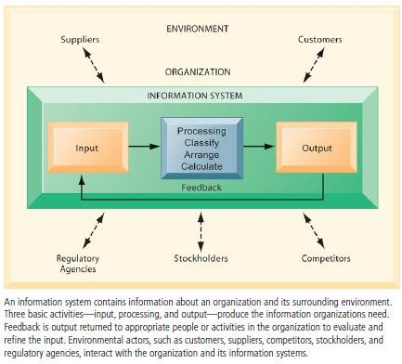
- The two types of information systems are formal and informal.

- Formal information systems are based on accepted and fixed definitions of data and procedures for collecting, storing, processing, disseminating, and using these data with predefined rules.
- Informal information systems, in contrast, relay on unstated rules.
- Formal information systems can be manual as well as computer based. Manual information systems use paper-and-pencil technology. In contrast, computer-based information systems (CBIS) relay on computer hardware and software for processing and disseminating information.

Dimensions of Information Systems:
- An information system represents a combination of Management, Organization, and Technology
elements.
- The management dimension of information systems involves leadership, strategy, and management behavior.
- The technology dimensions consist of computer hardware, software, data management technology, and networking/telecommunications technology (including the Internet).
- The organization dimension of information systems involves the organization ‘s hierarchy, functional specialties, business processes, culture, and political interest groups.
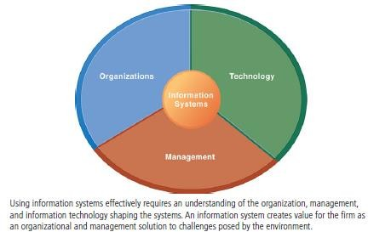

Organization
- Organizations are formal social units developed to the attainment of specific goals. The key elements of an organization are its people, structure, operating procedures, politics, culture, and functional specialties.
  - People: Organizations require many different kinds of skills and people like managers (such as senior, middle, and operational) who make decisions and plans to solve organizational problems, knowledge workers (such as engineers, architects, or scientists) who design products or services and create new knowledge, data workers (such as secretaries, bookkeepers, or clerks) who process the organizations paperwork, and

production or service workers (such as machinists, assemblers, or packers) who actually produce the organizations products or services.
  - Structure: Organizations coordinate work through a structured hierarchy. The hierarchy arranges people in a pyramid structure of rising authority and responsibility. The upper levels of hierarchy consist of managerial, professional, and technical employees, whereas the lower levels consist of operational personnel.
  - Standard Operating Procedures (SOPs): Standard operating procedures (SOPs) are formal rules that have been developed over a long time for achieving organizational goals. Firm ‘s business processes are based on its SOPs.
  - Organizational Politics: People in organization occupy different positions with different specialties, concerns and perspectives. As a result, they naturally have divergent and differing viewpoints about how Resources, Rewards, and Punishments should be distributed. This will result in political struggle for resources, competition and conflict within every organization.
  - Organizational Culture: It is a set of fundamental assumptions about what products the organization should produce, how it should produce them, where, and for whom. Organizational culture is a powerful restraint on change, especially technology change. Any technological change that threatens commonly held cultural assumptions usually meets a great deal of resistance.
  - Business Functions: The major business functions, or specialized tasks performed by business organizations include sales and marketing (selling the organization ‘s products and services), manufacturing and production (producing products and services), finance (managing the organization ‘s financial assets like cash, stocks, etc.), accounting (maintaining the organization ‘s financial assets and accounting the flow of funds), and human resources (attracting, developing, and maintaining the organization‘s labor force; maintaining employee records).
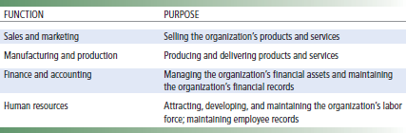

Management
- Management ‘s job is to make decisions and formulate action plans to solve organizational problems.
- Managerial roles and decisions vary at different levels of the organization.
- Senior managers occupy the topmost hierarchy and are responsible for making long-range decisions.
- Middle managers occupy in the middle of the organizational hierarchy who are responsible for carrying out the plans and goals of senior management.
- Operational managers monitor the day-to-day activities of the organization.

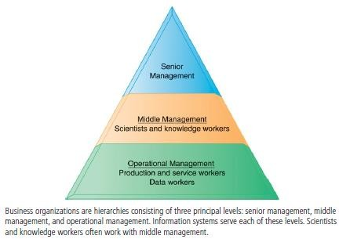

- Managers play an important role in organizations. We can understand managerial functions by examining classical and contemporary models of managerial behavior.
  - Classical Models of Management: The classical descriptions of management focus on five classical functions of managers like planning, organizing, leading, and controlling. These terms actually describe formal managerial functions and are unsatisfactory as a description of what managers actually do in their jobs. For example, these terms do not address what managers actually do when they plan, decide things, and control the work of others.
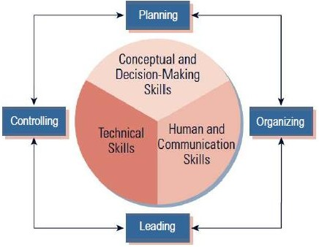

- Above figure shows systems relationship among the management functions.
- Planning includes setting objectives and determining in advance exactly how the objectives will be met.
- Organizing means delegating and coordinating tasks and allocating resources to achieve objectives.
- Managers should also show leadership. He/she should influence employees to work towards achieving objectives.
- Controlling means managers should establish and implement mechanisms to ensure that objectives are achieved.

  - Behavioral Models of Management: These models describe management based on what managers actually do in their jobs. Managers ‘day-to-day behavior can be classified into multiple managerial roles. Managerial roles are expectations of activities that managers should perform in an organization. These roles fall into three categories: interpersonal, informational, and decisional.
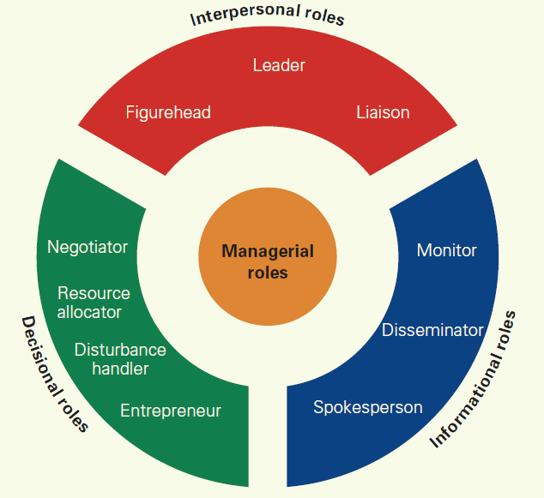
- Interpersonal Roles: Interpersonal management roles are grouped into three roles involving working with other people. Managers act as figureheads, leaders, and liaisons (cooperation/co-ordination).
- Informational Roles: Informational management roles are divided into three different communication-based roles. Managers act as monitors, disseminators (distributors), and spokespersons.
- Decisional Roles: Decisional management roles are sorted into four action-based roles for making and implementing decisions. Managers act as entrepreneurs, disturbance handlers, resource allocators, and negotiators.

Information Technology
- Information technology is the tool used by managers to deal with change. The technology dimension consists of computer hardware, software, data management technology, and networking/telecommunications technology.
- Computer Hardware: It is the physical equipment used for input, processing, and output activities in an information system. It consists of processing unit; various input, output, and storage devices; and physical media to link these devices together.
- Computer Software: It consists of detailed preprogrammed instructions that control and coordinate the work of computer hardware components in an information system.
- Data Management Technology: In order to keep track of all of the information stored, we need data management software that is designed to organize the information so that we can readily retrieve what we are looking for.
- Networking and Communications technology: It includes physical devices and software that link various computer hardware components that transfer data from one physical location to another. This technology helps to connect computers and communication equipment for sharing voice, data, images, sound, or video in networks. A network links two or more computers to share data and resources. The world’s largest and most widely used network is the Internet.
All the above technologies collectively form the firm ‘s information technology (IT) infrastructure. The IT infrastructure provides the foundation or platform on which the firm can build its specific information systems. So, each organization must carefully design and manage its IT infrastructure according to the needs of the information system.

